**Learning Management System (LMS)**

**The learning management system is based on three modules**

* Trainee
* Trainer
* Admin (Super Admin)

**Admin Module**

**The Login Page -**

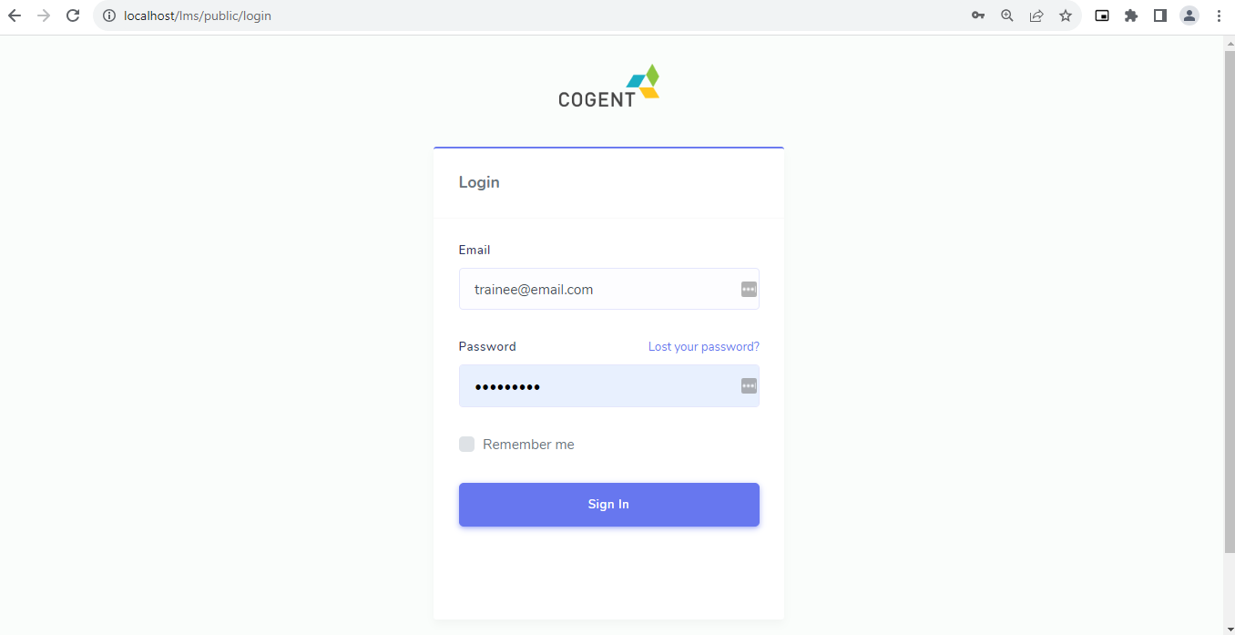

* For the Admin, the email id and password will be given for login.
* After logging in, the Admin will be redirected to the Dashboard.

**The Dashboard Page -**

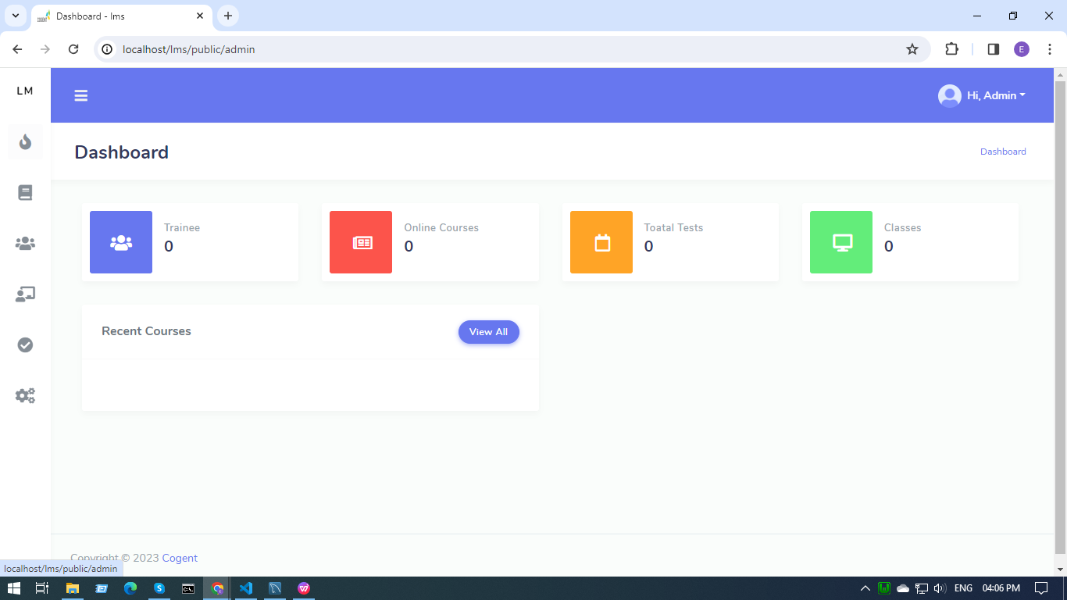

* All the counts of trainees, courses, tests and classes are displayed here.
* All the tabs are clickable.
* Admins can add trainer, tests, courses and classes.

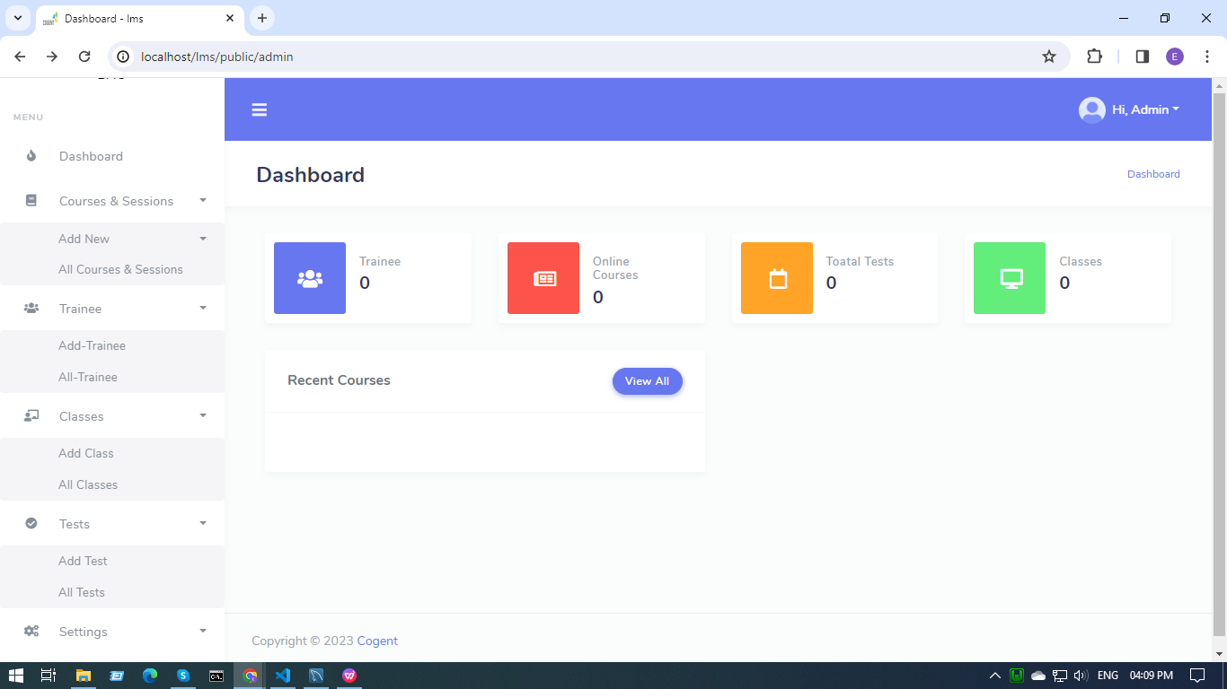

* Admins can add,delete and edit the types of roles.

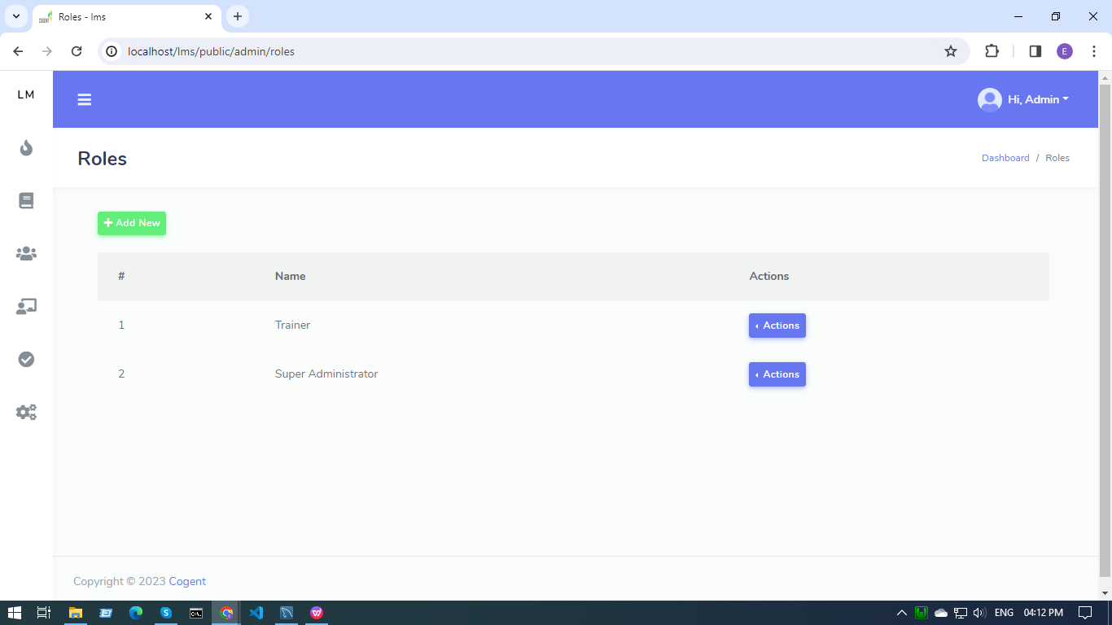

* Admins can allow different permissions for different roles.

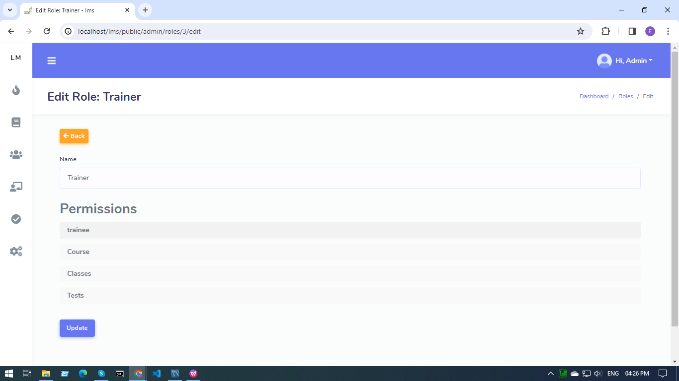

**Settings - Administrators/Trainers -**

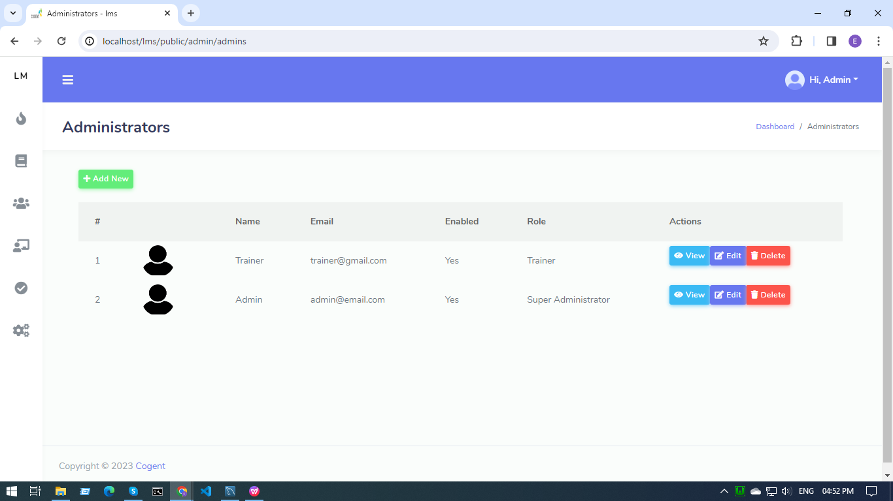

* admin can manage the trainer's details.

**Add New Courses and Sessions -**

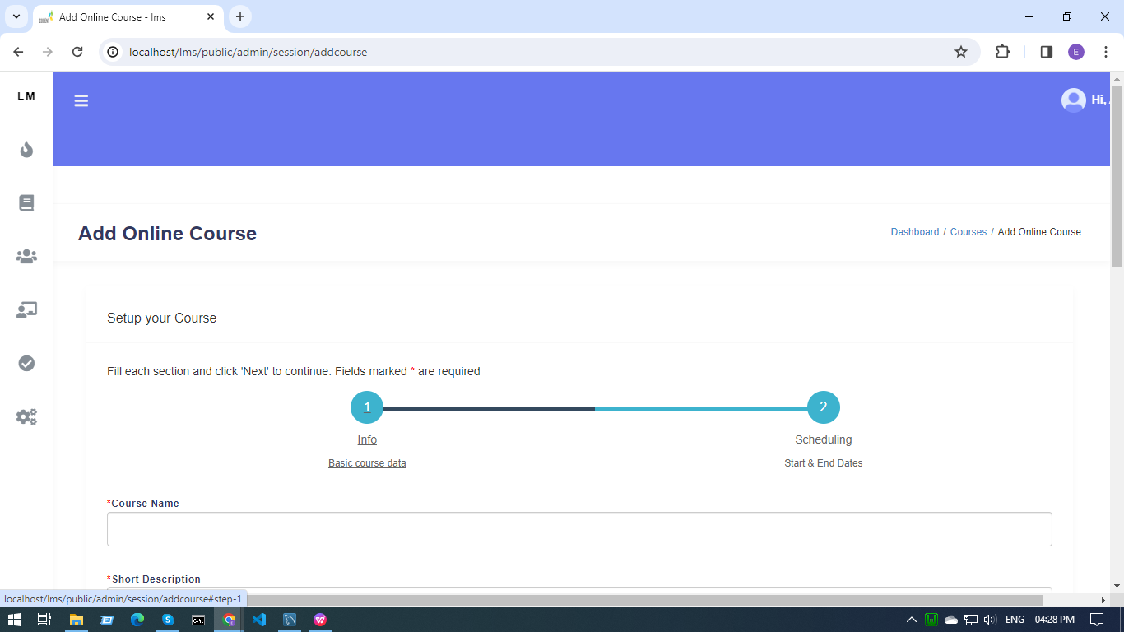

* Admins can add new online courses.
* Set the course duration.

**All Courses and Sessions -**

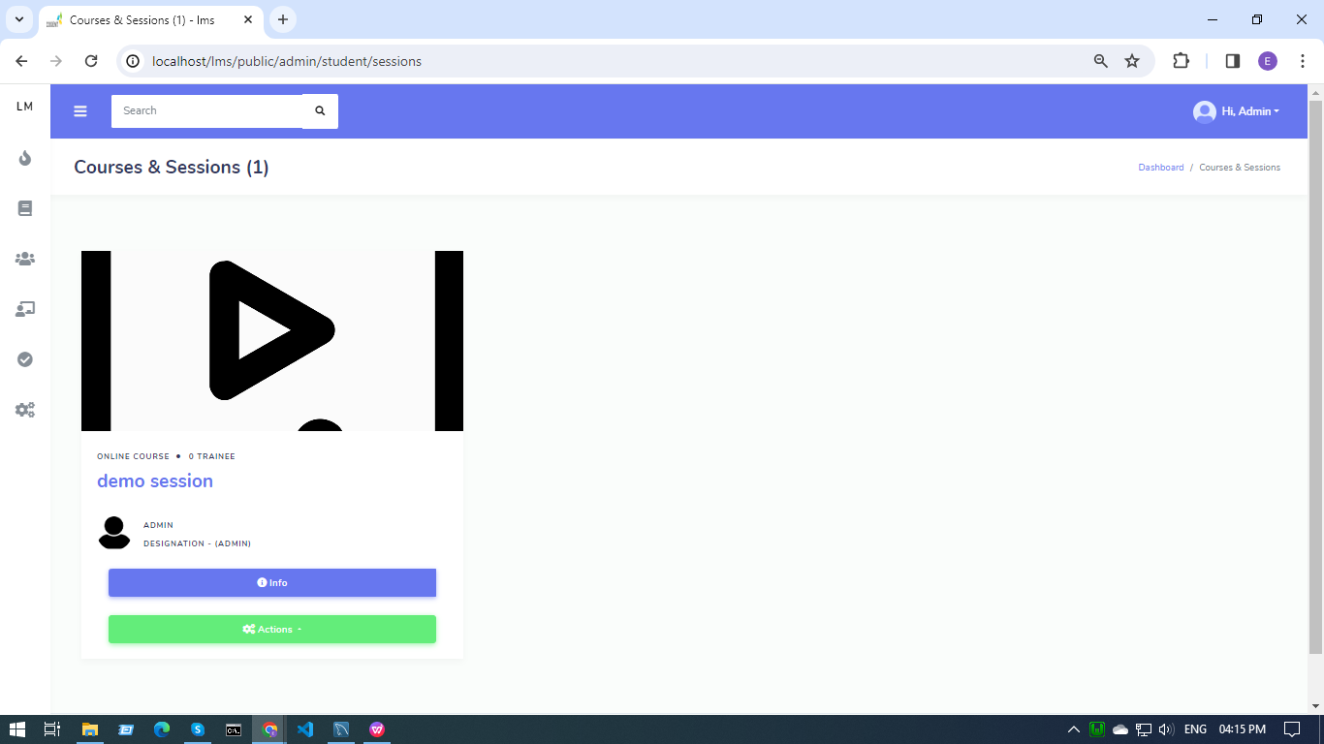

* By clicking on info, a modal opens up with all the course details.

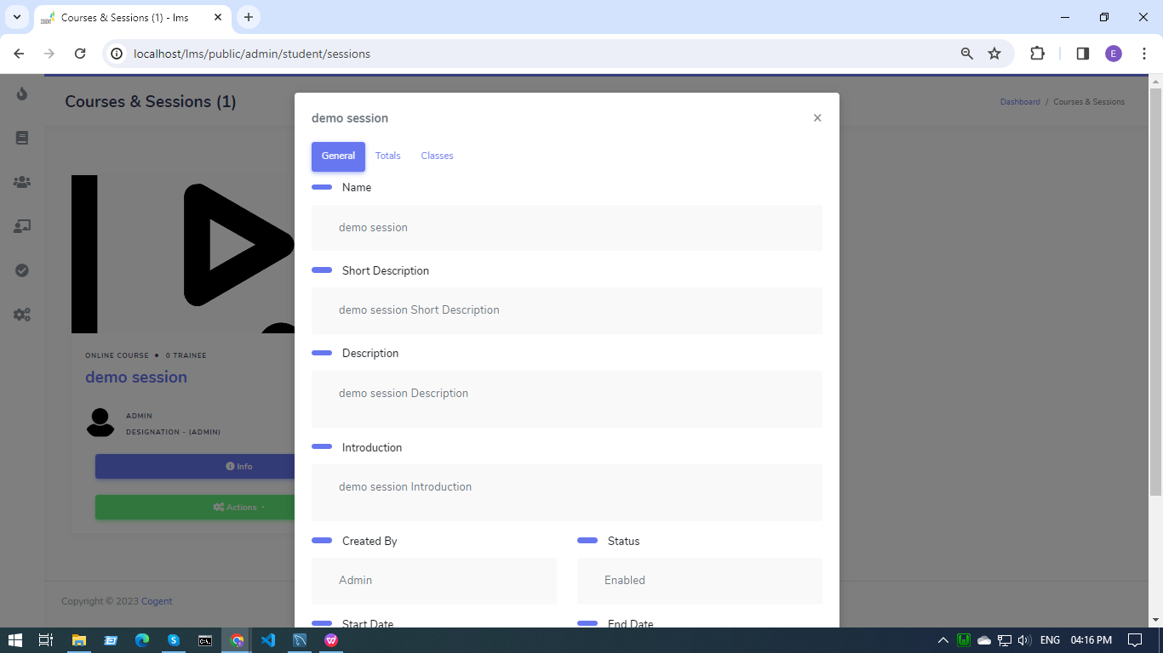

* Admin can edit courses, manage tests, trainees enrolled and classes on course.

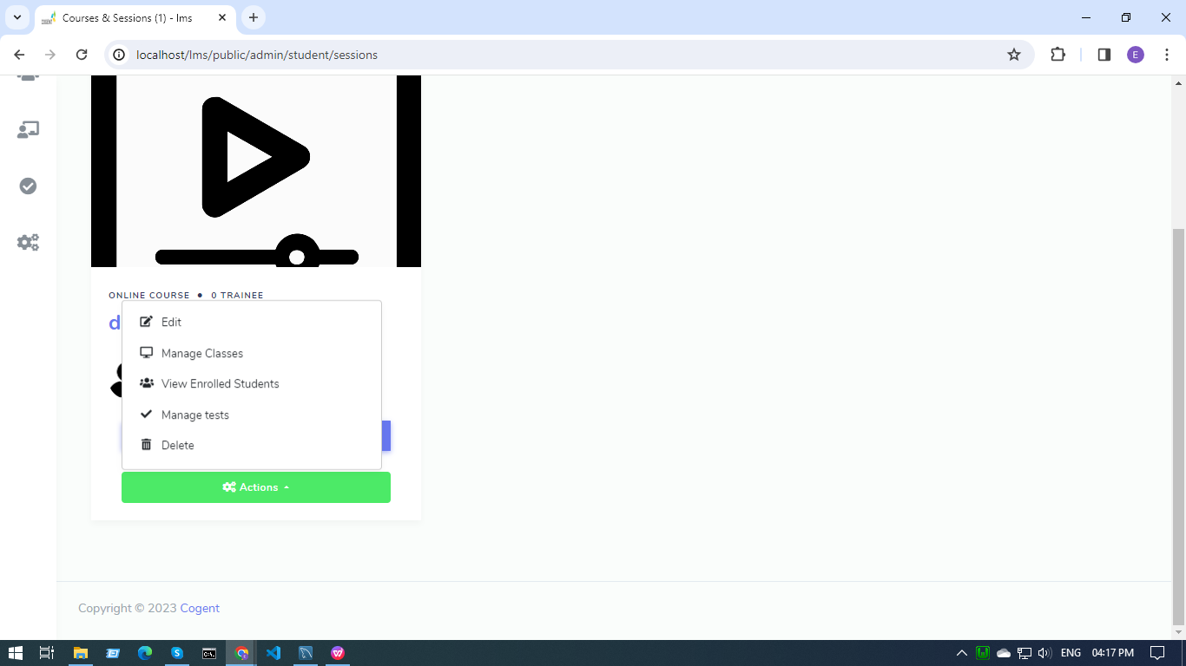

* Clicking on manage classes, manage class page opens up to either make a new class or to add classes to courses that already exist.

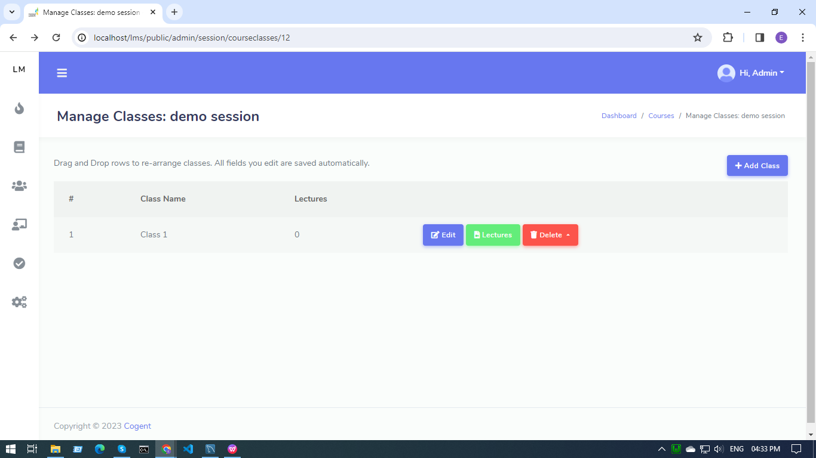

* Clicking on manage tests, the manage test page opens up to either make a new test or to add tests to courses that already exist.

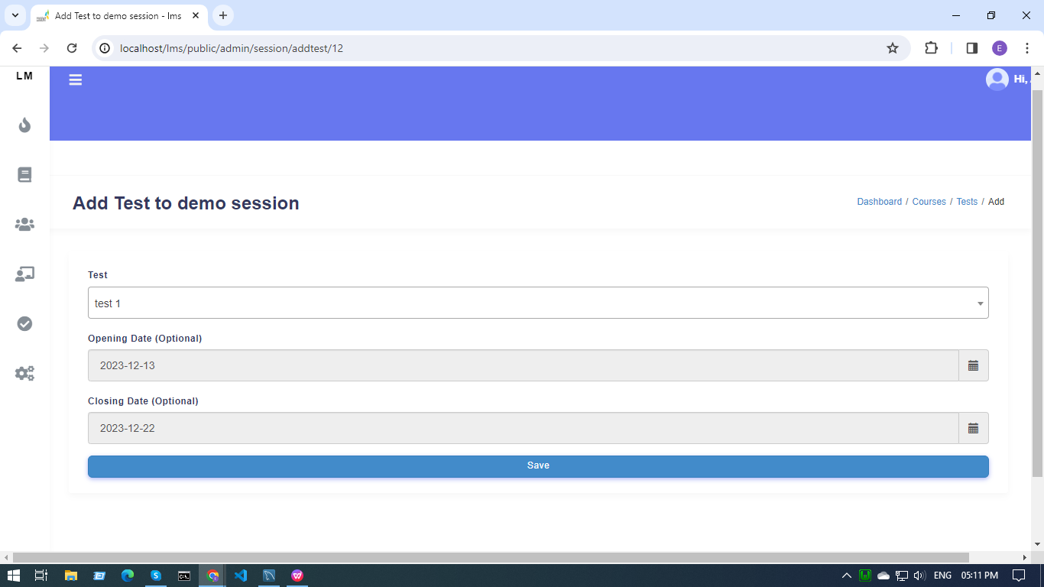

**Add Classes -**

* Trainers can add class details like class name, type,etc details and create a class.

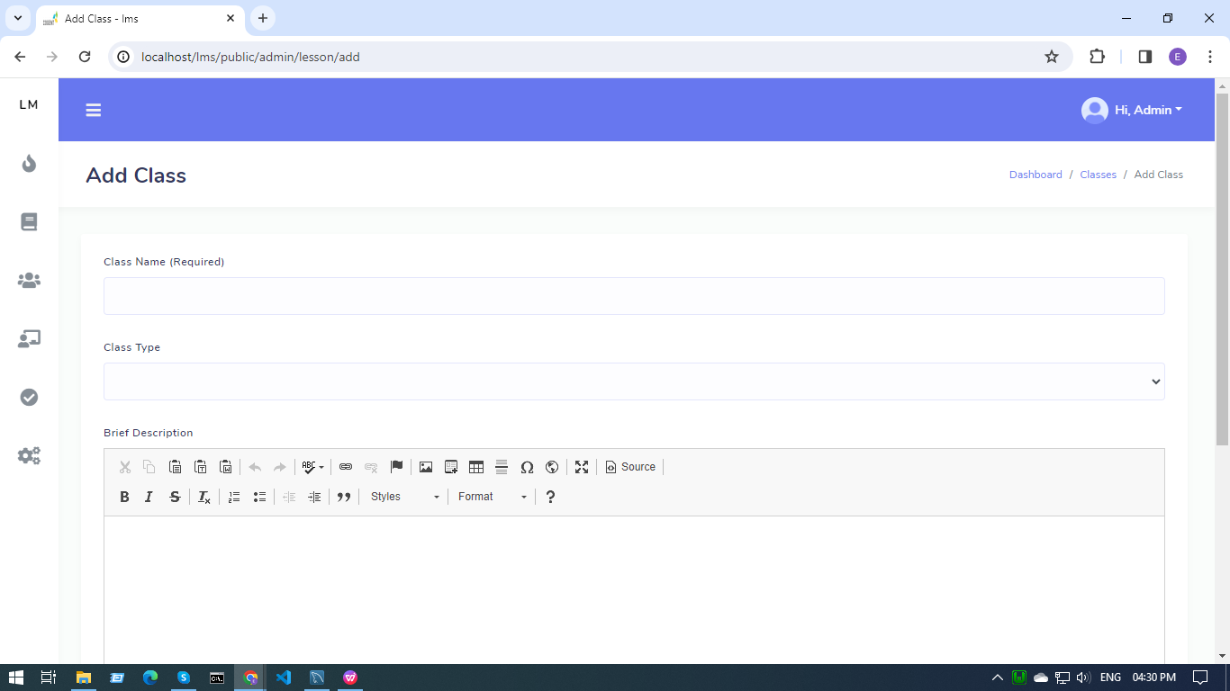

**All Classes -**

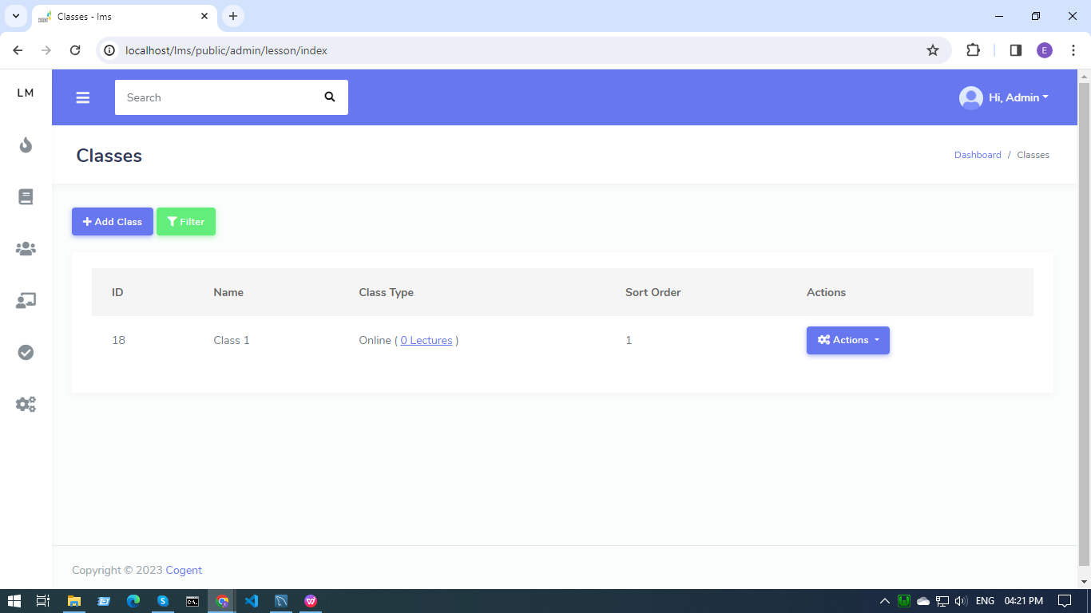

* Admins can add, delete and edit classes by clicking on the action button.
* By clicking on the manage lecture option in the action section, Admin can add, delete and edit lectures.

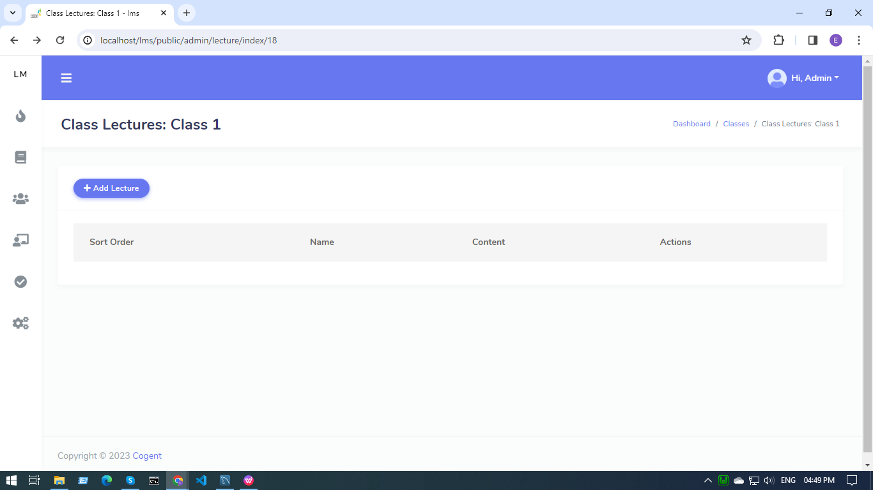

* And then add lecture content

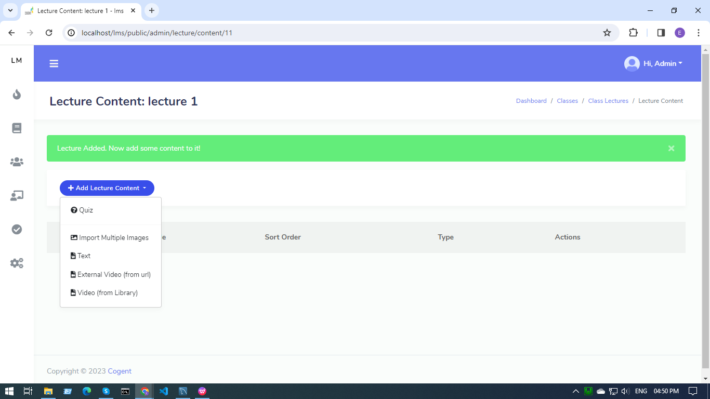

* If the content type is quiz, then a modal opens for quiz details like title and description.

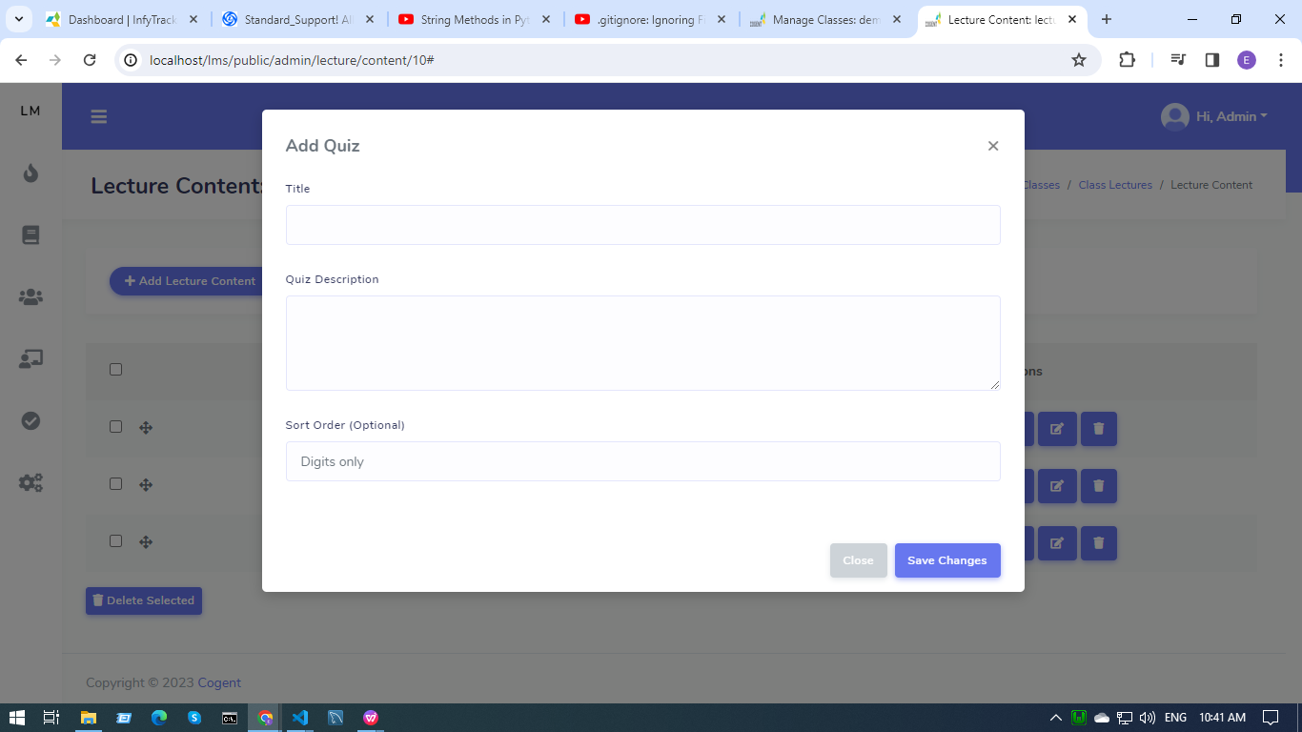

* After clicking on the save changes button, the admin will be redirected to the Edit quiz page that contains the level of performance message (100% - Level 1 , 80% - Level 2, 70% - Level 3, 50% - level 4 and below 50% are in level 5).

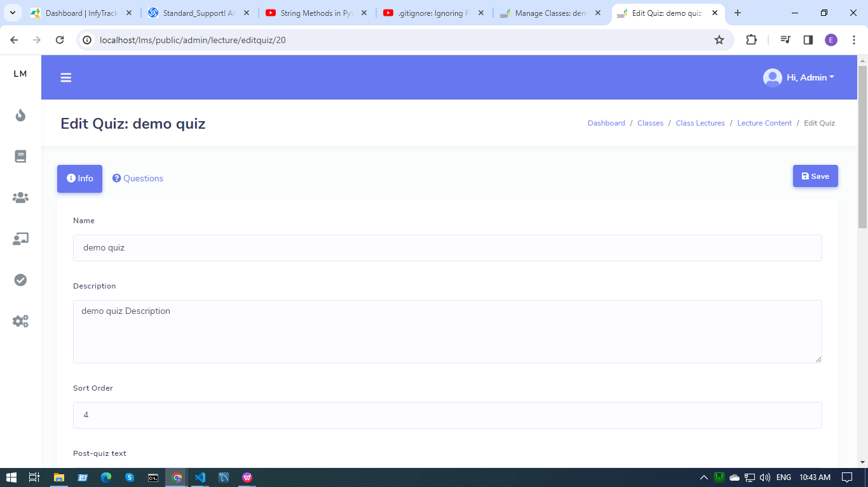

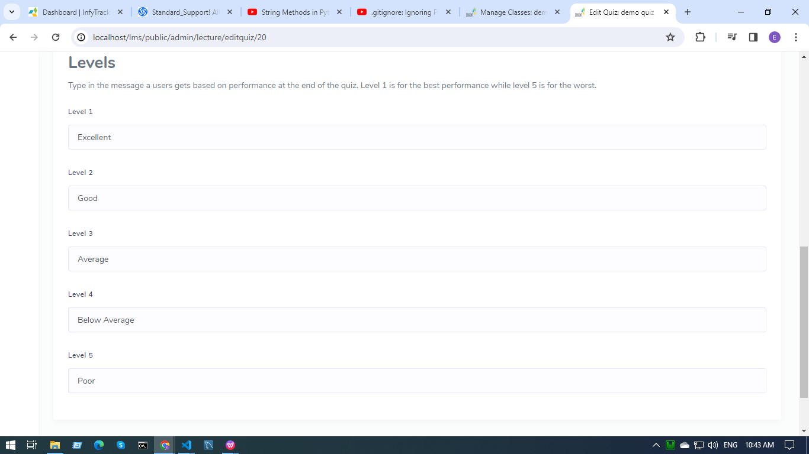

* By clicking on the question button, the admin can add the quiz questions and options.

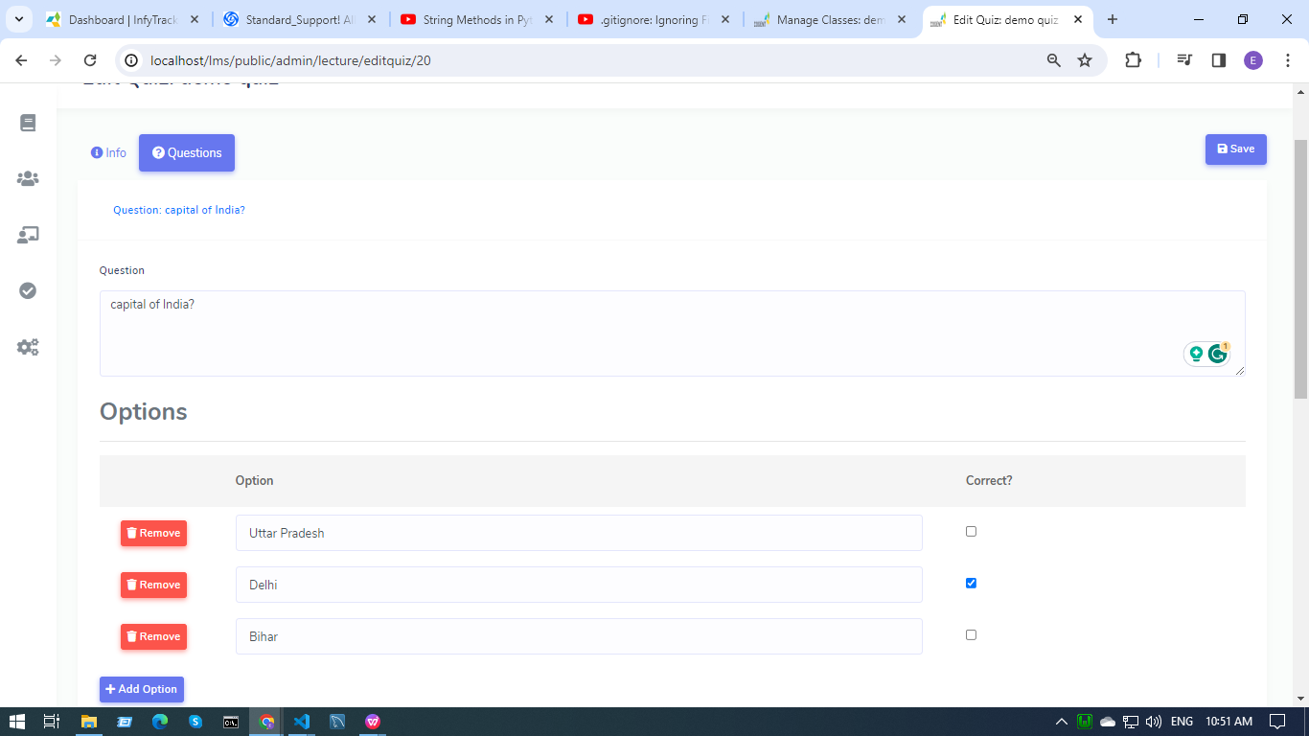

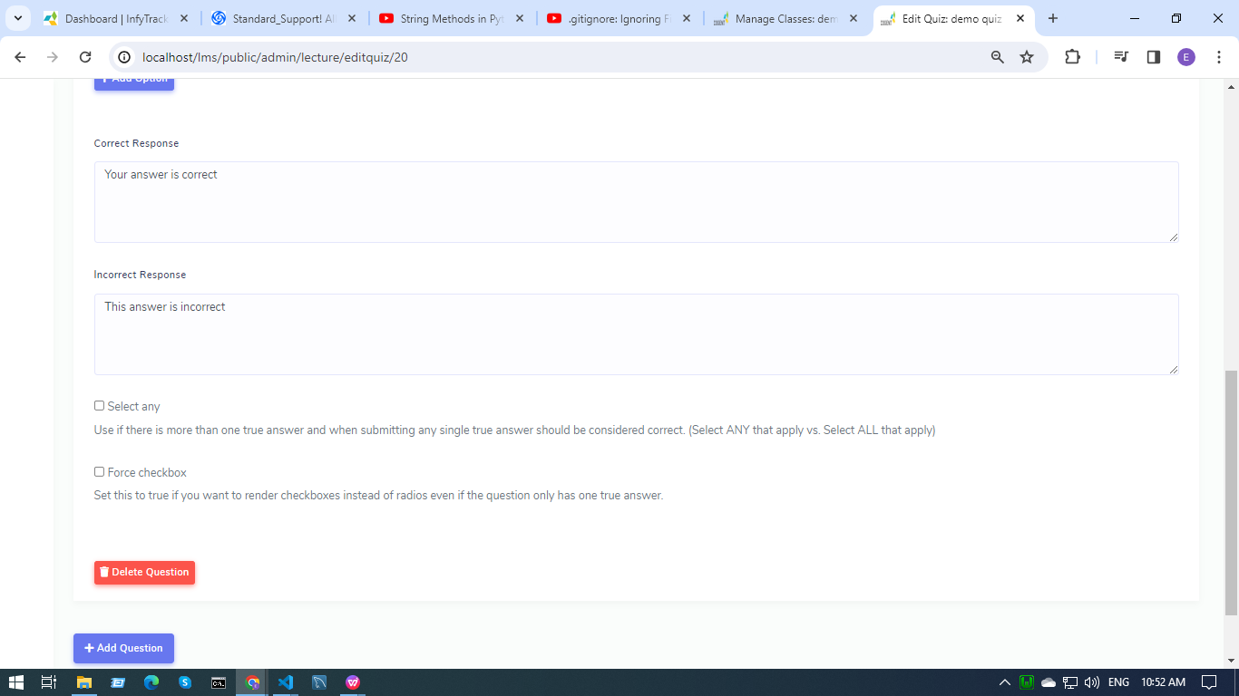

* If the content type is video, then the admin can upload pre-recorded videos or can upload video URLs.

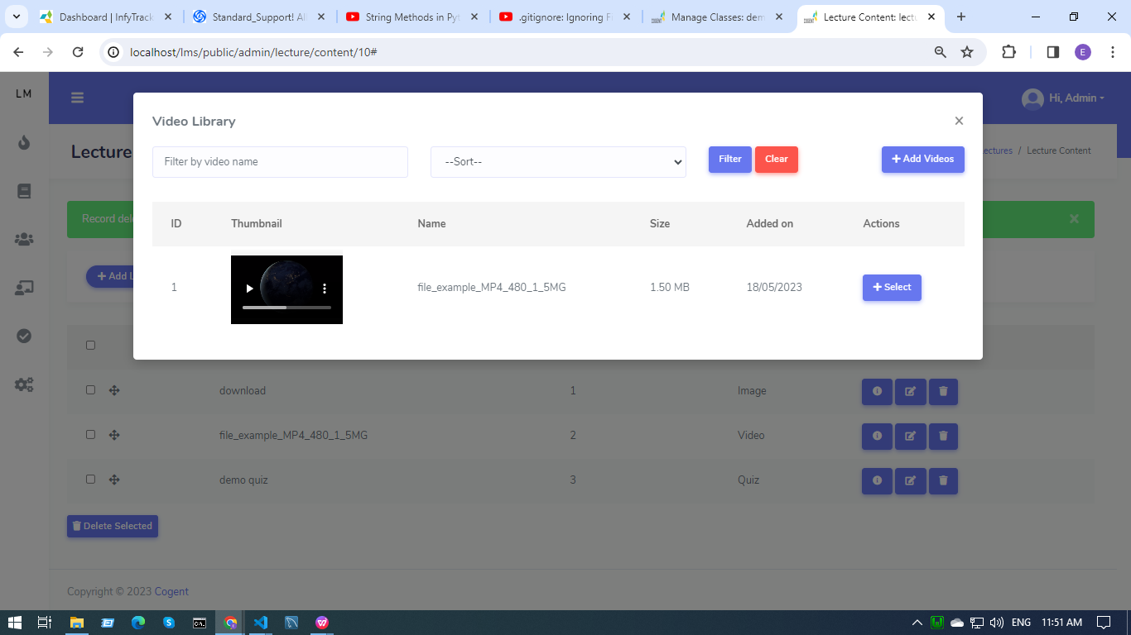

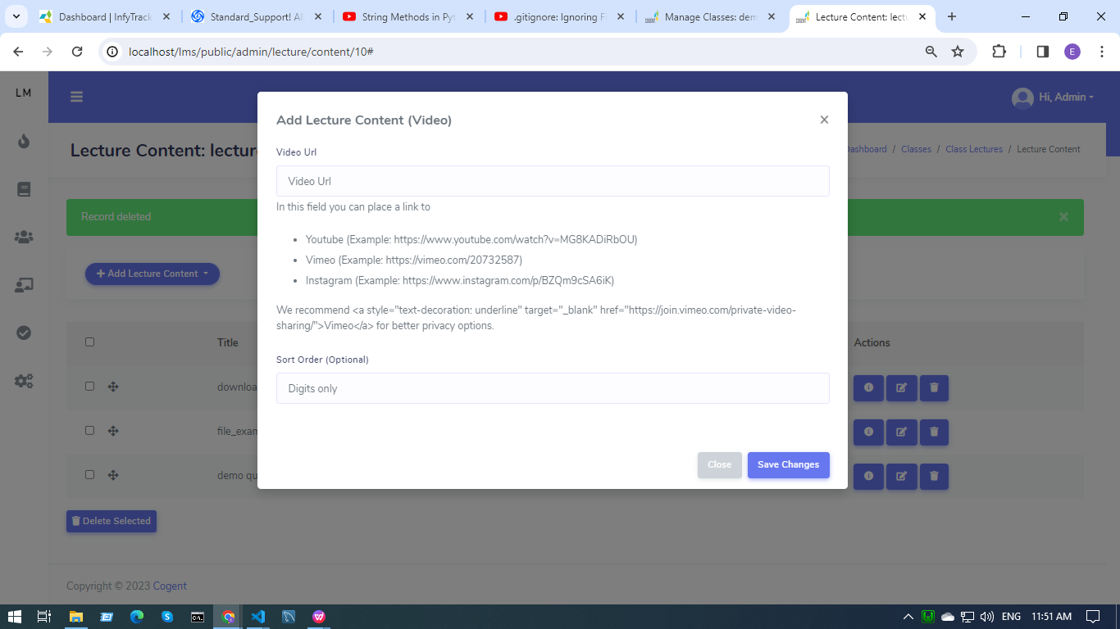

* The content in the lectures can be managed, added, deleted, realigned,etc.

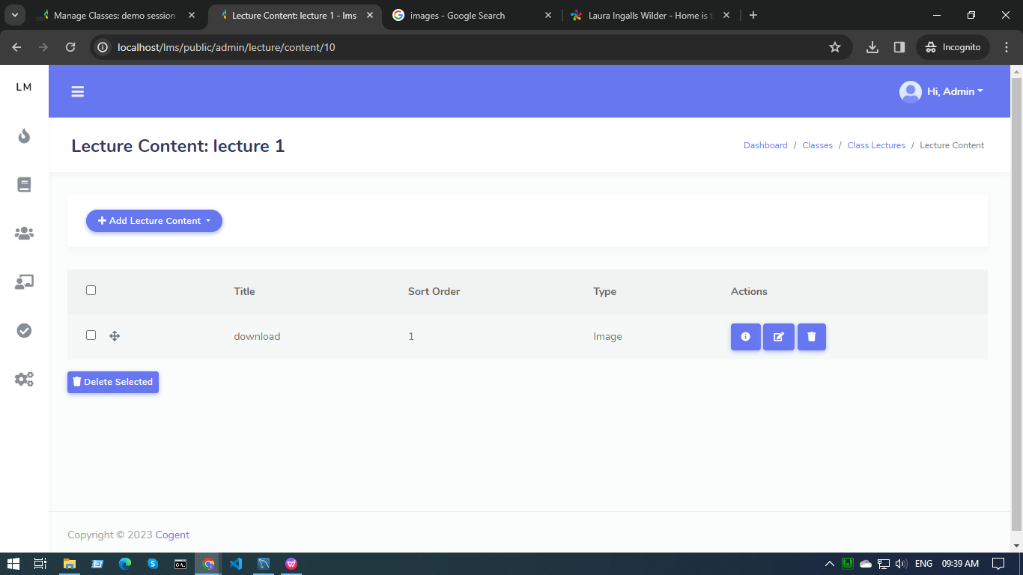

**Add Test -**

* Admins can add test details like test name, instructions, number Of attempts, test duration, pass marks, etc.

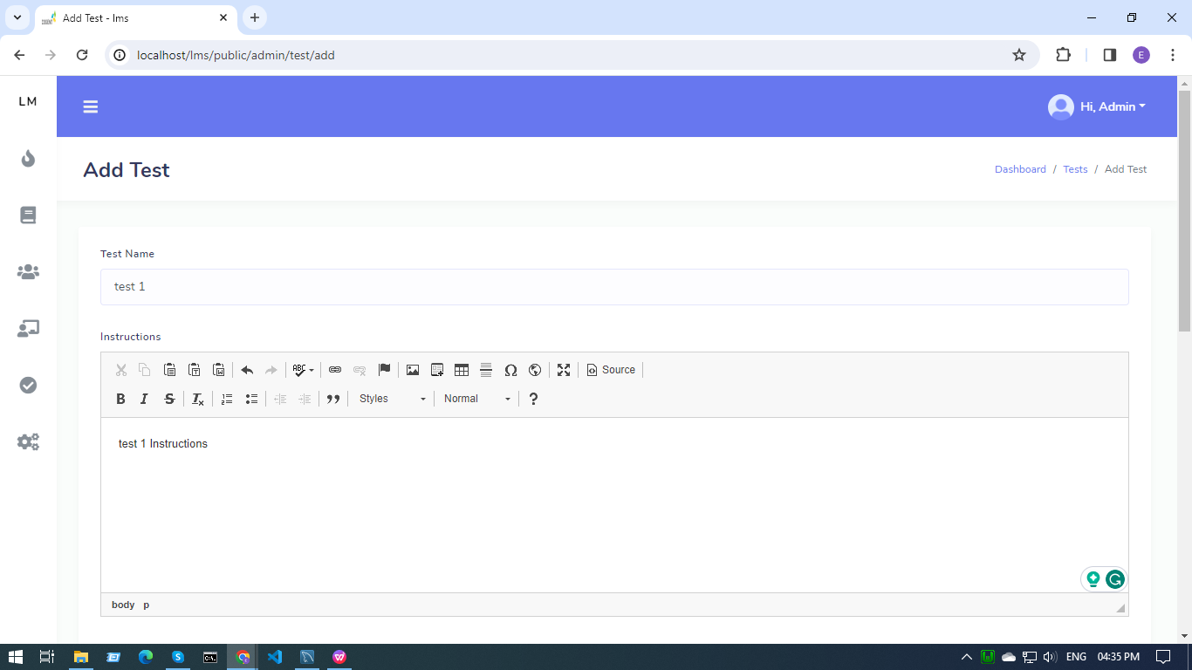

* Then the admin can add or import the test questions to the test -

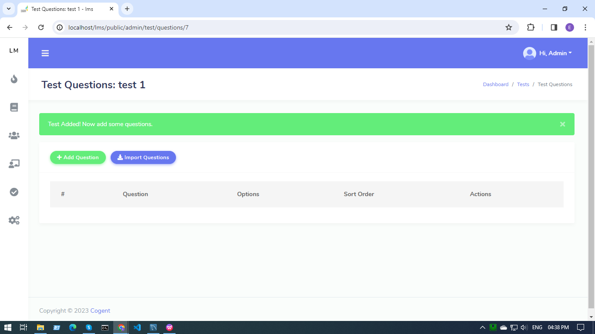

* By clicking on the add question button, a modal pops open and the admin can add question details like question , correct answer and its options.

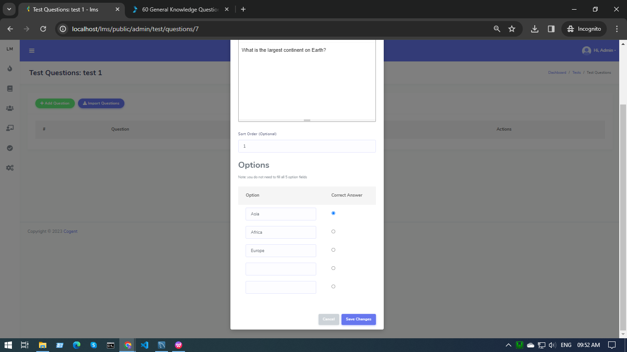

* By clicking on import questions button a modal opens to import the csv file and admin can download the format in which the file must be uploaded.

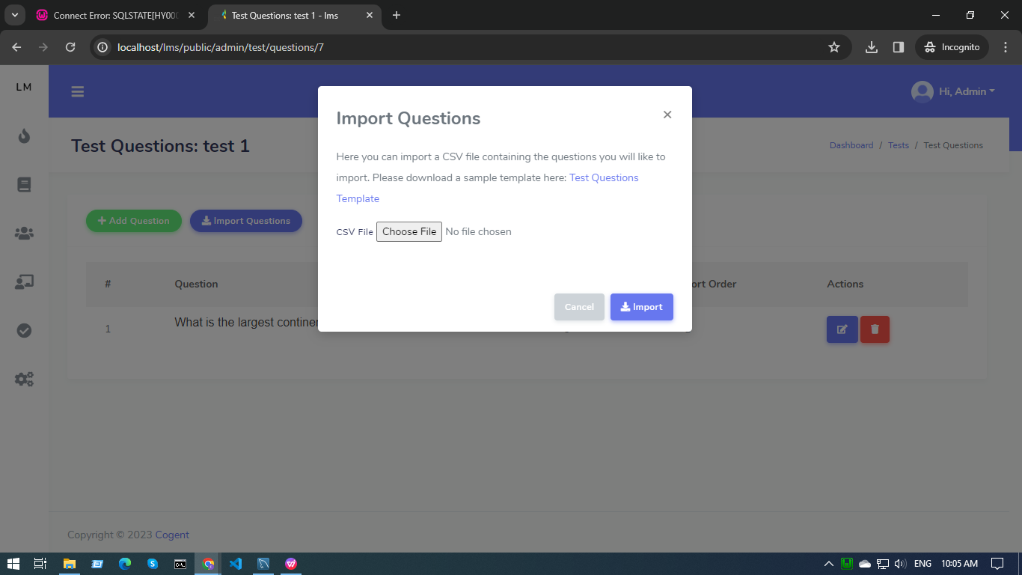

**All Test -**

* The admin can add, edit the test and view the number of attempts on the test.

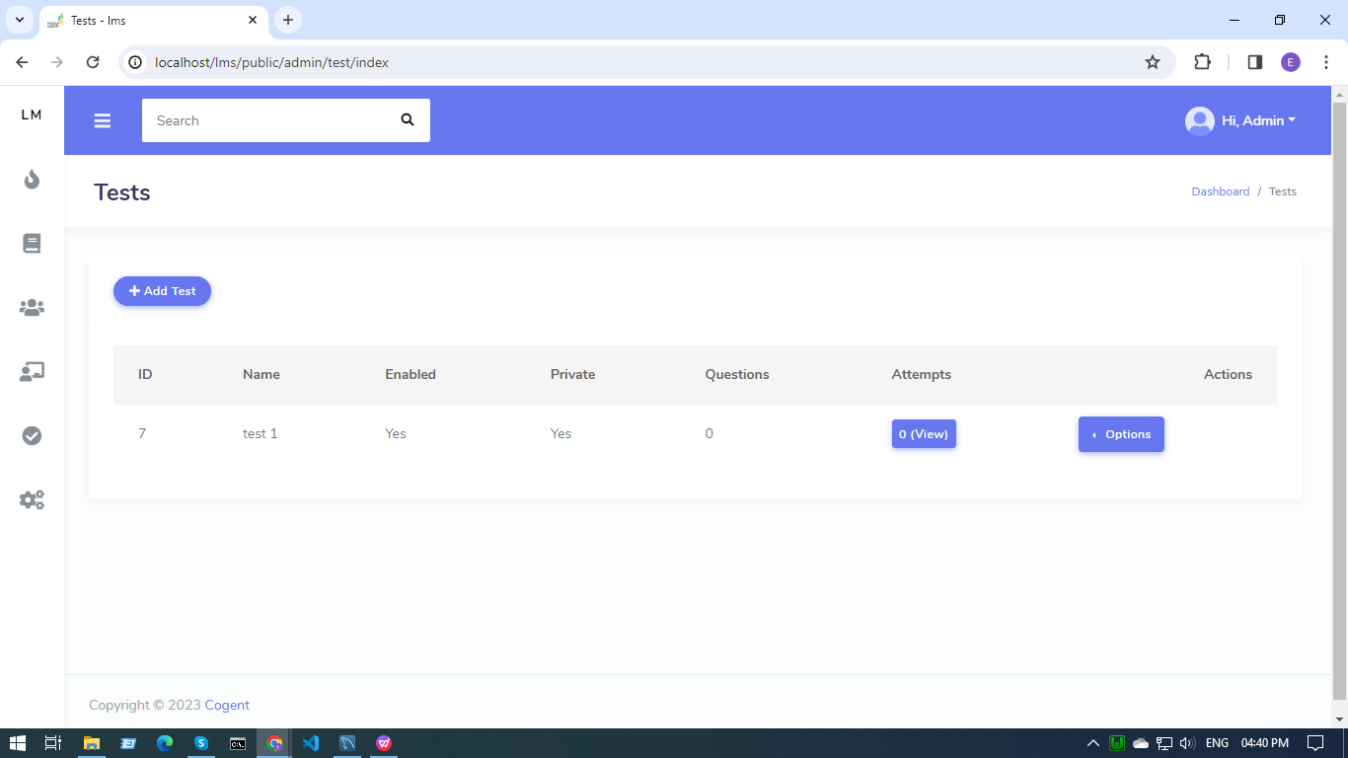

* By clicking on the view button, admin can see test attempt details.

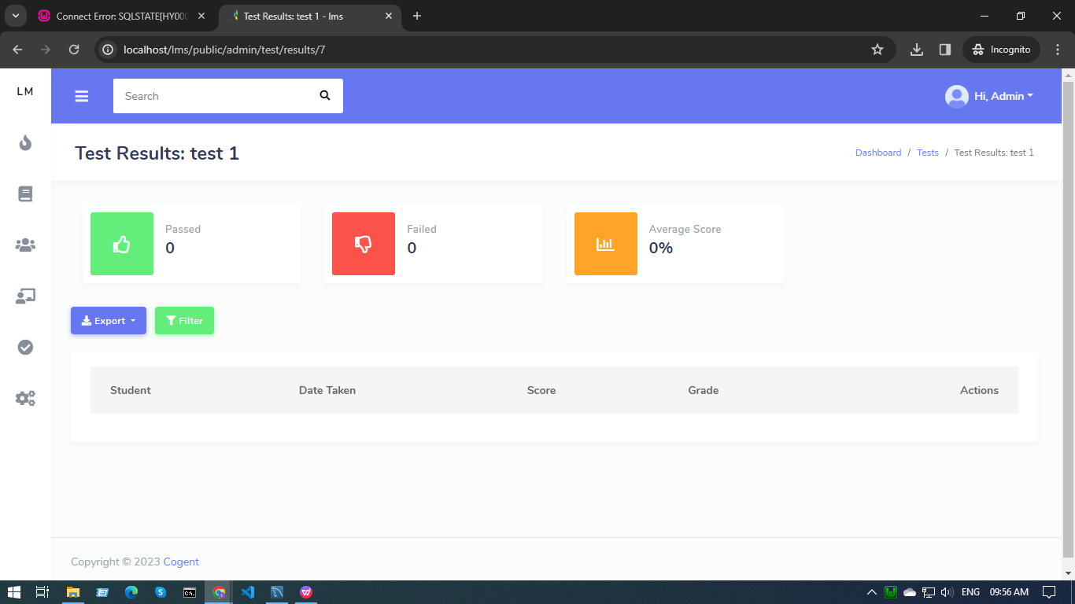

* By clicking on the export button, the admin can decide to export the data of trainee who passed or failed in category.

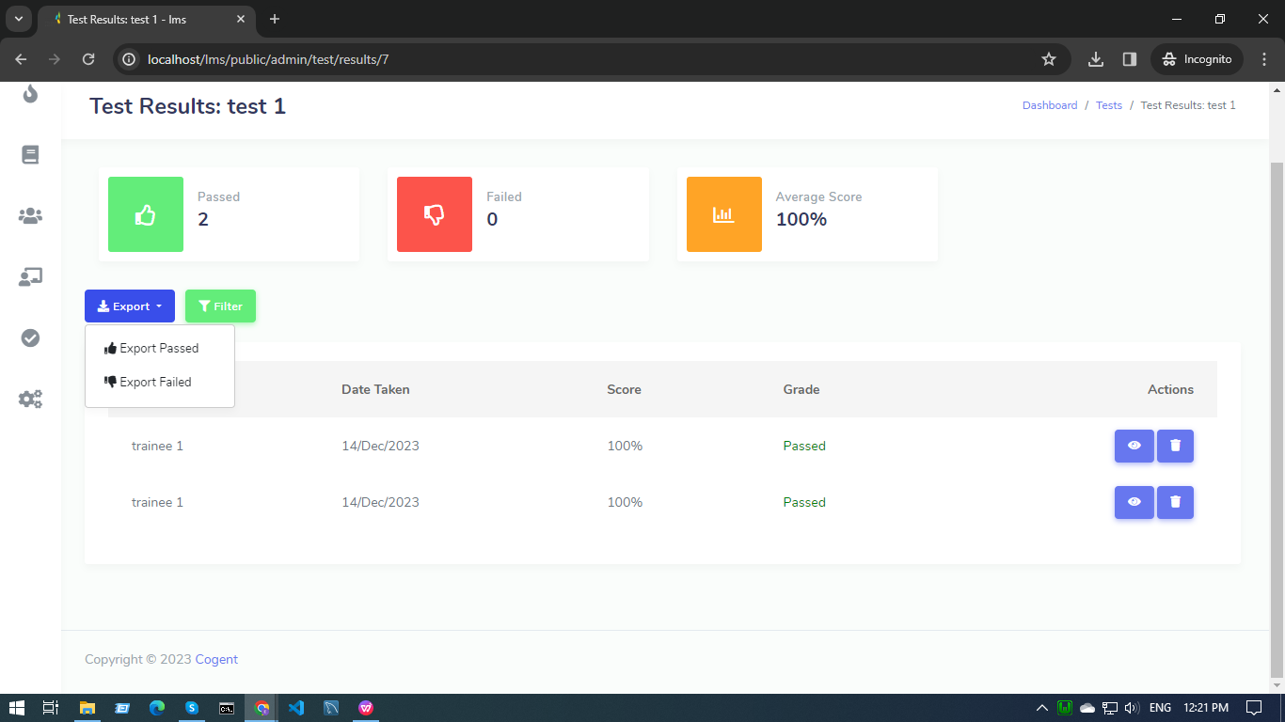

**Add Trainee -**

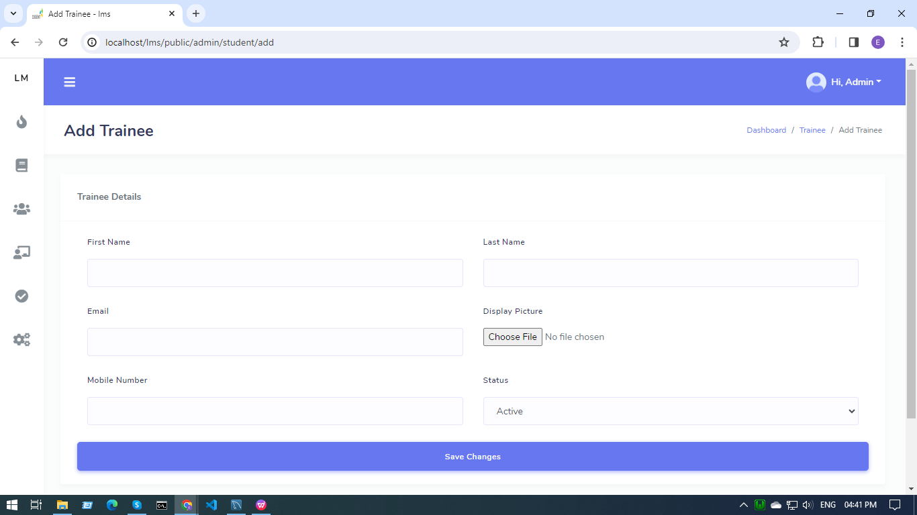

* Admins can add trainee details like : name, email, profile picture, etc. And submitted , then the trainee details will be added to the system.

**All Trainees -**

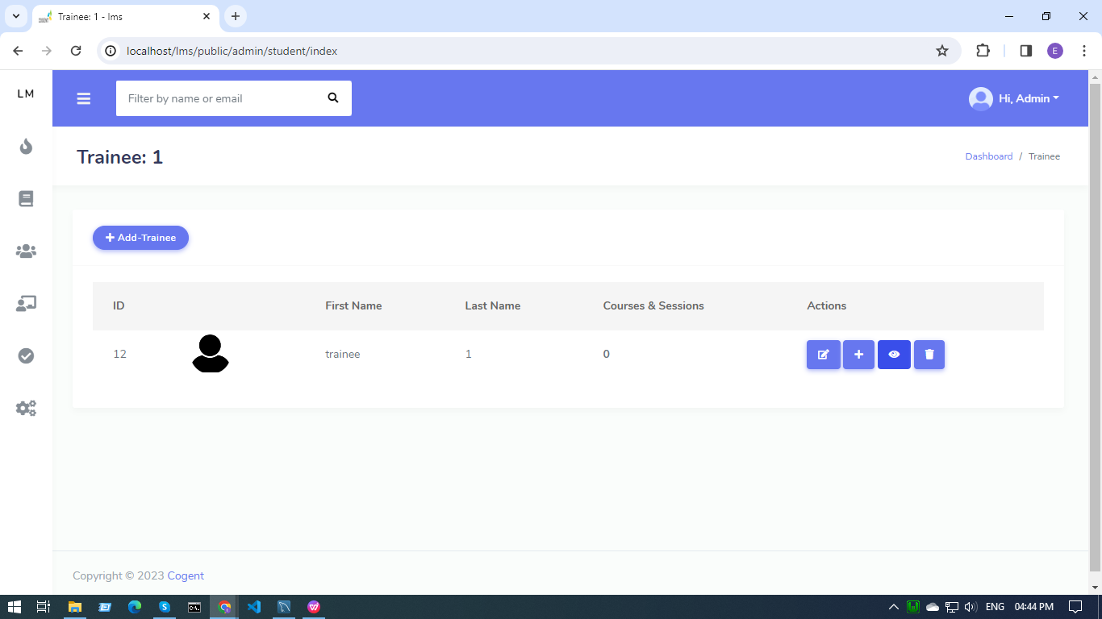

* Admins can add more trainees.
* Admin can edit, enroll ,view details and delete the already existing trainee details.

**Trainer Module**

**The Login Page -**



* For the Trainer, the email id and password will be given for login.
* After logging in, the Trainer will be redirected to the Dashboard.

**The Dashboard Page -**



* All the counts of trainees, courses, tests and classes are displayed here.
* All the tabs are clickable.
* Trainers can add trainer, tests, courses and classes.



**Add New Courses and Sessions -**



* Trainers can add new online courses.
* Set the course duration.

**All Courses and Sessions -**



* By clicking on info, a modal opens up with all the course details.



* Trainers can edit courses, manage tests, trainees enrolled and classes on course.



* Clicking on manage classes, manage class page opens up to either make a new class or to add classes to courses that already exist.



* Clicking on manage tests, the manage test page opens up to either make a new test or to add tests to courses that already exist.



**Add Classes -**

* Trainers can add class details like class name, type,etc details and create a class.



**All Classes -**



* Trainers can add, delete and edit classes by clicking on the action button.
* By clicking on the manage lecture option in the action section, Trainers can add, delete and edit lectures.



* And then add lecture content



* If the content type is quiz, then a modal opens for quiz details like title and description.



* After clicking on the save changes button, the trainer will be redirected to the Edit quiz page that contains the level of performance message (100% - Level 1 , 80% - Level 2, 70% - Level 3, 50% - level 4 and below 50% are in level 5).





* By clicking on the question button, the trainer can add the quiz questions and options.





* If the content type is video, then the trainer can upload prerecorded videos or can upload video URLs.





* The content in the lectures can be managed, added, deleted, realigned,etc.



**Add Test -**

* Trainers can add test details like test name, instructions, number of attempts, test duration, pass marks, etc.



* Then the trainers can add or import the test questions to the test -



* By clicking on the add question button, a modal pops open and the trainers can add question details like questions , correct answer and its options.



* By clicking on import questions button a modal opens to import the csv file and Trainers can download the format in which the file must be uploaded.



**All Test -**

* The Trainers can add, edit the test and view the number of attempts on the test.



* By clicking on the view button, trainers can see test attempt details.



* By clicking on the export button, the trainer can decide to export the data of trainee passed or failed in category.



**Add Trainee -**



* Trainers can add trainee details like : name, email, profile picture, etc. And submitted , then the trainee details will be added to the system.

**All Trainees -**



* Trainers can add more trainees.
* Trainers can edit, enroll ,view details and delete the already existing trainee details.

**Trainee Module**

**The Login Page -**



* For the first time - trainee will login with an email id and the password will be trainee mobile no.
* After the first time login, trainees can change their password. Go to the profile icon and click on change password.

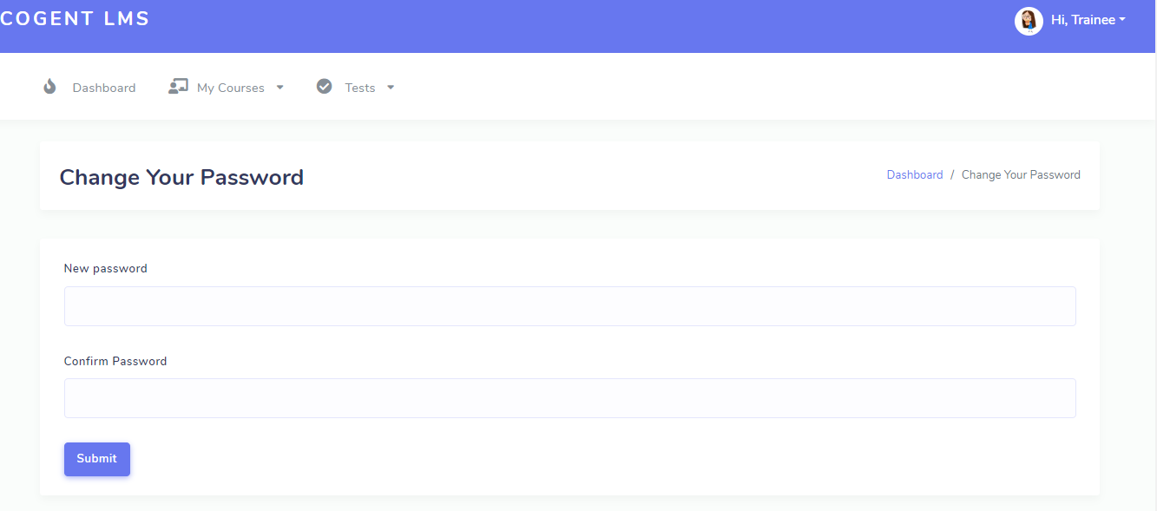

**The Dashboard Page -**

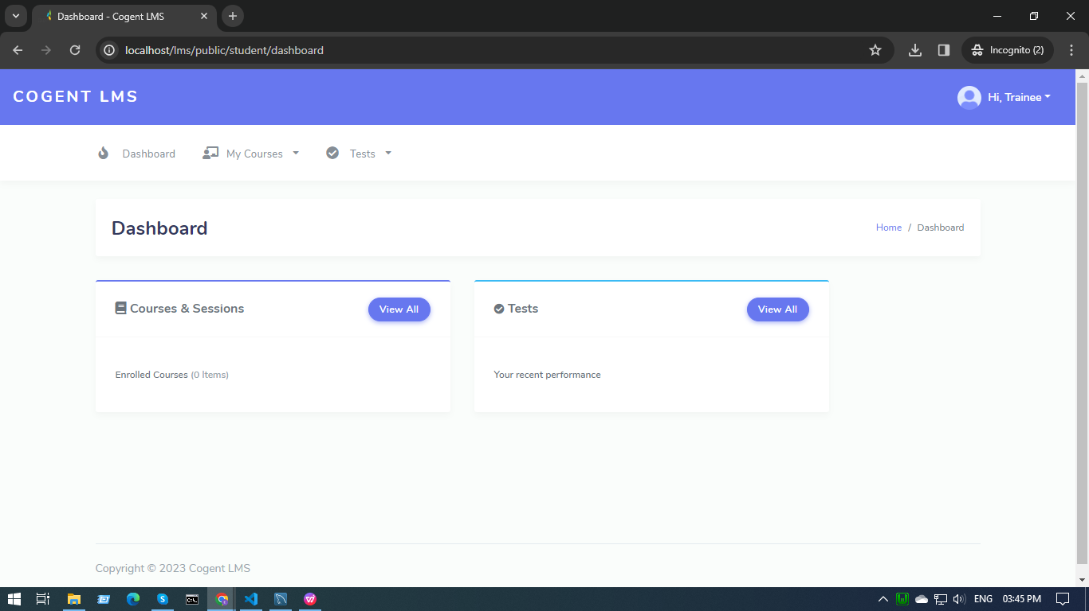

* Trainees can see the courses/sessions and tests they are enrolled in by clicking on the view button.
* If the course link has expired, then it will be displayed on the screen.

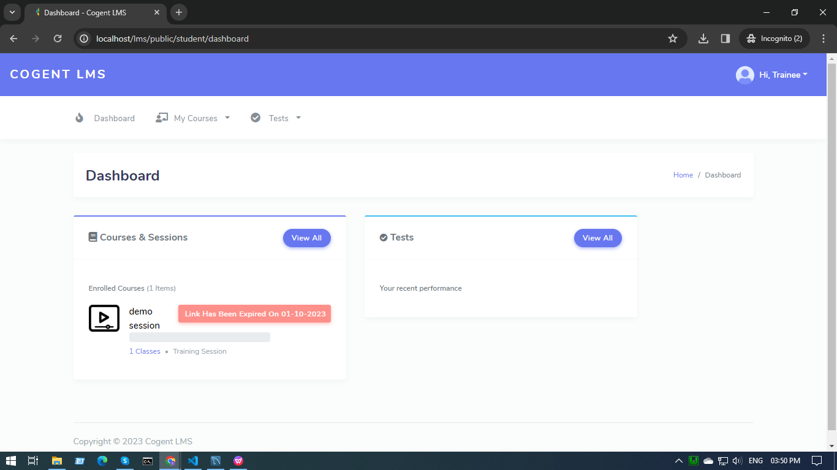

* If the course link has not expired, then the course will be displayed on the screen.

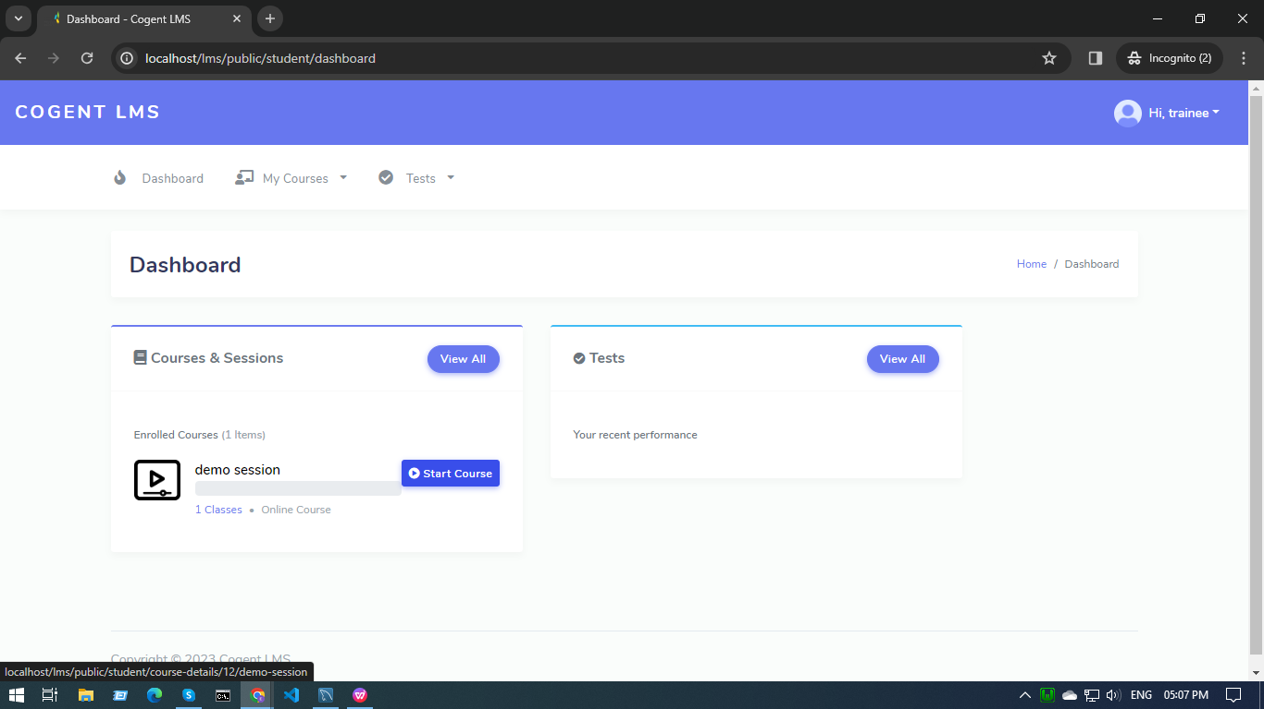

* When a trainee clicks on the start course button -

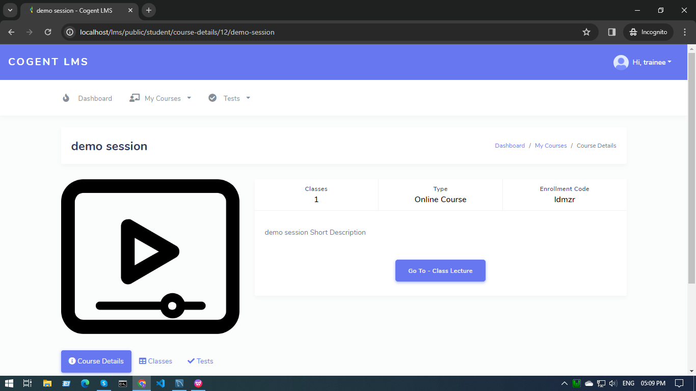

* The test will not start until all the lectures in a class are attempted and all the classes are completed.

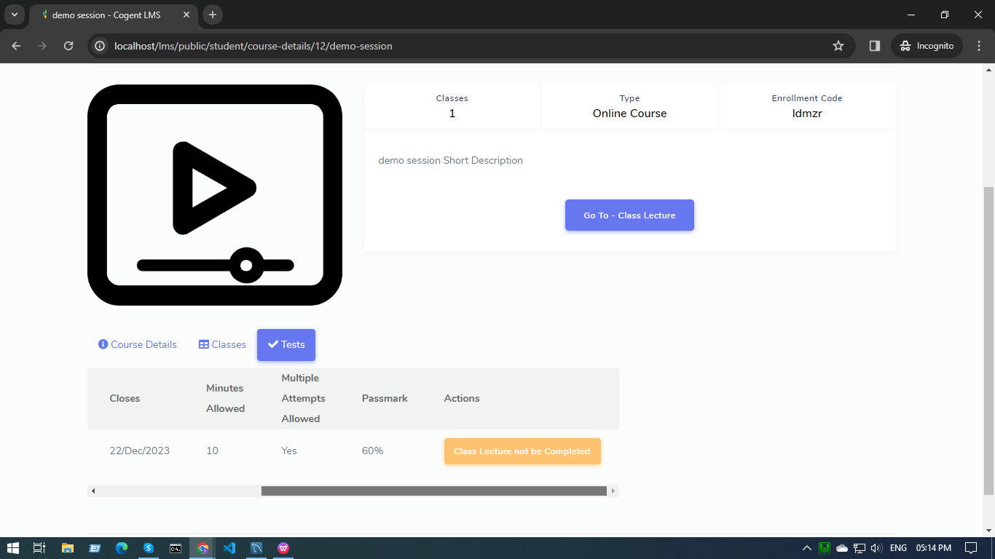

* By clicking on go to - class lecture, we can access all the lectures class by class.

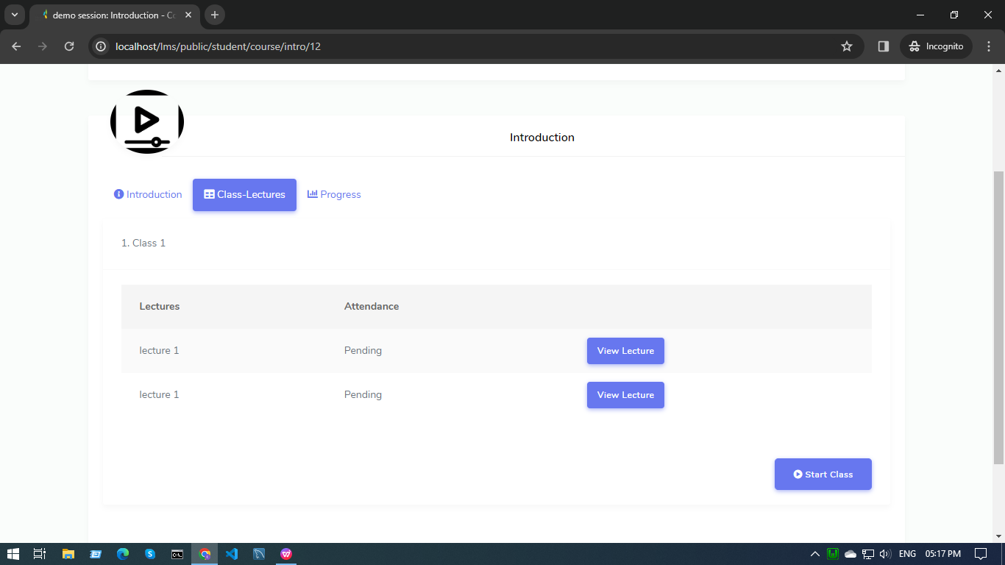

* Lecture 2 will only open after lecture 1 is marked completed. And once the lecture is marked as complete, it can be accessed anytime again by the trainee.

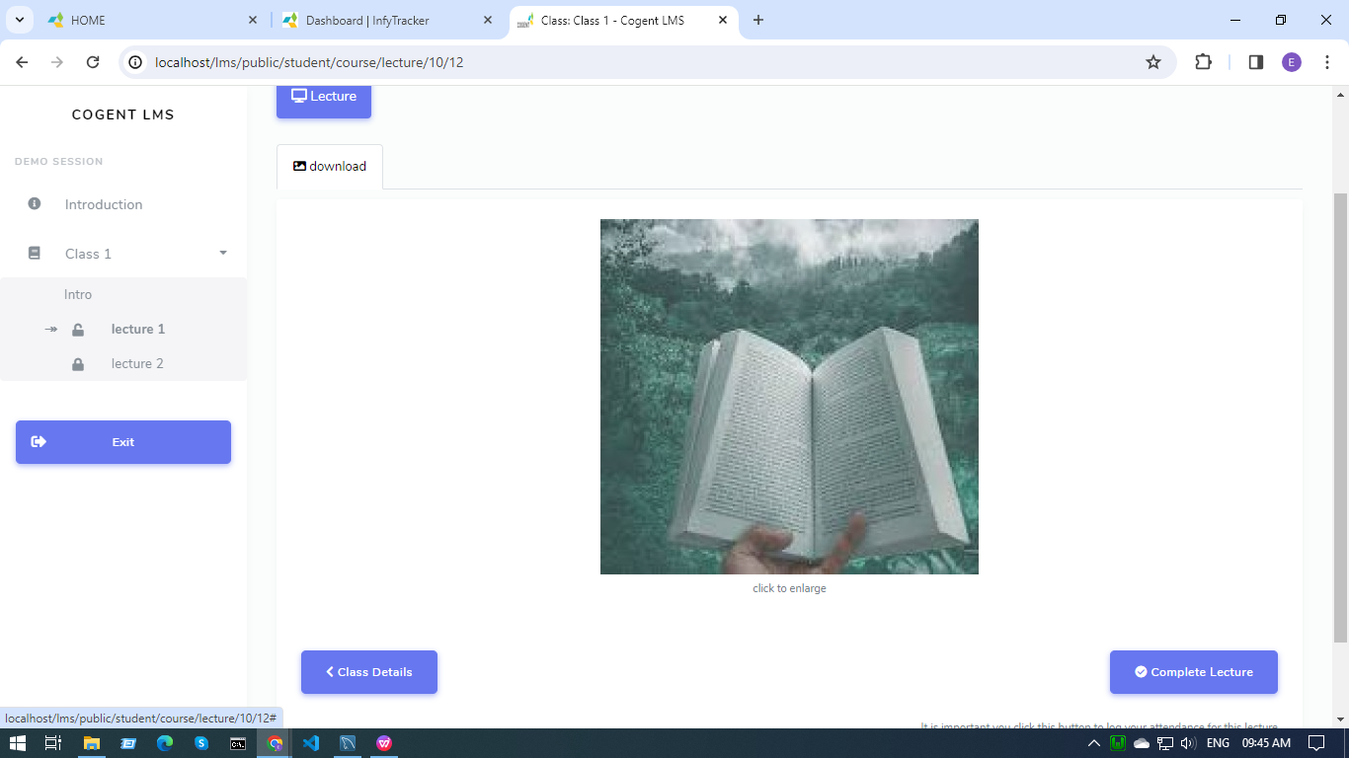

* Once all the lectures and classes are completed, the test will open.

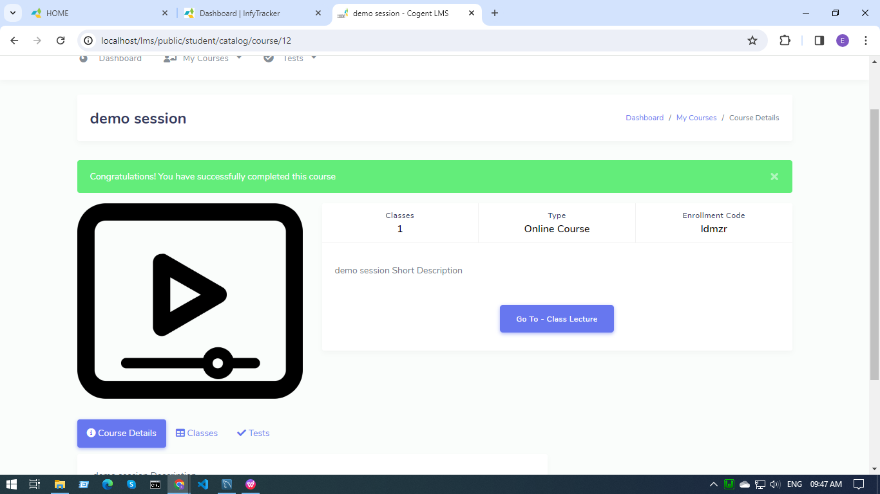

* By clicking on the Progress button, the trainee can track the course progress, know which classes are pending and which are attempted.

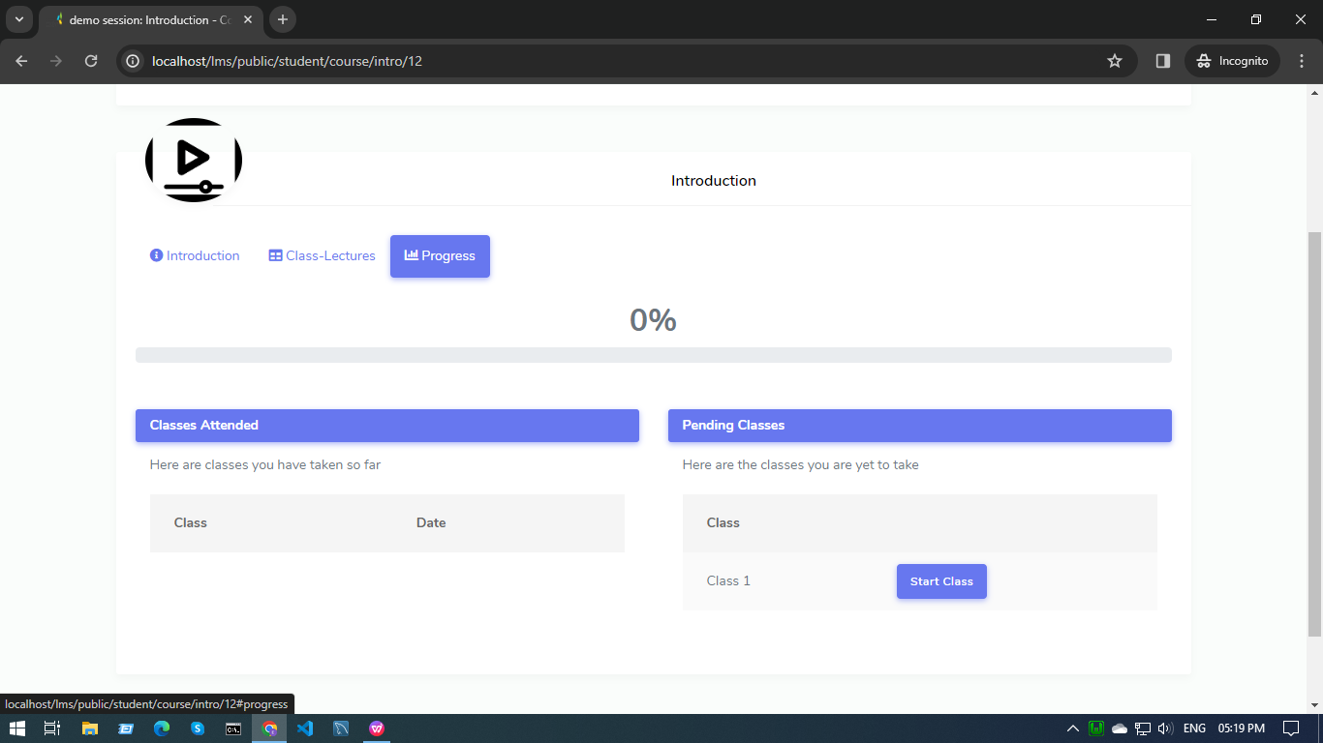

**The My Courses Page -**

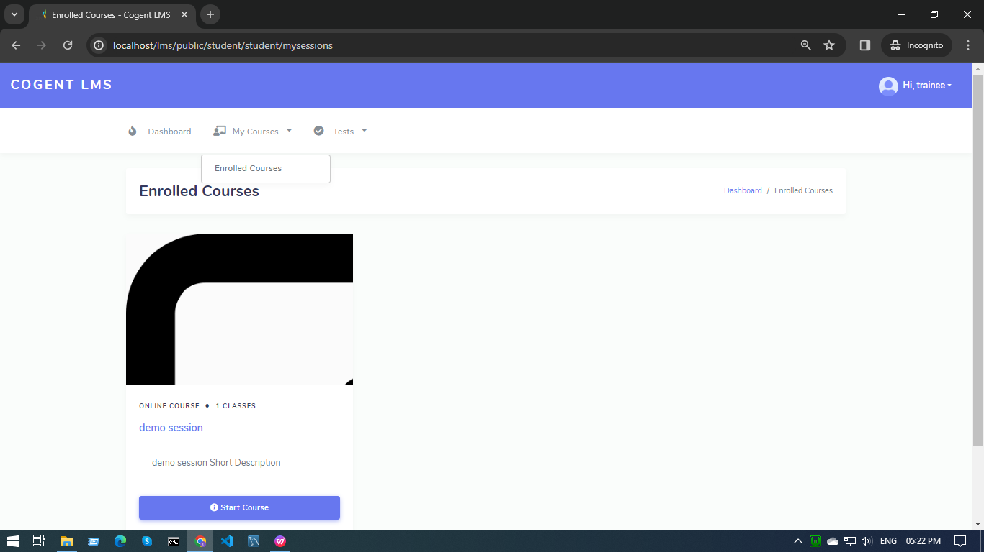

* By clicking on the My Course Tab, the trainee will be redirected to a page displaying all the courses the trainee is enrolled in.
* Trainees can click on the start course button and start the course.

**The Tests Page -**

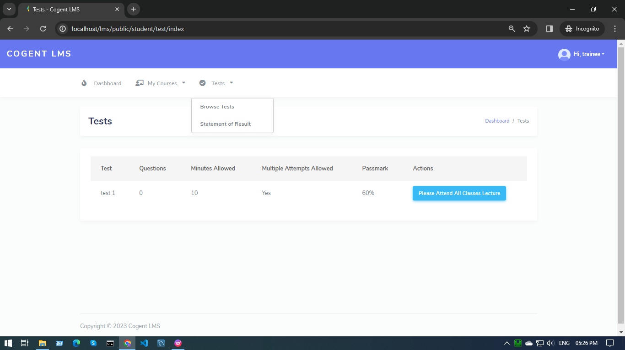

**(Browse Tests) -**

* By clicking on the Tests Tab - Browse Tests option, the trainee will be redirected to a page displaying all the tests the trainee is enrolled in.
* Trainees can click on the start test button and start the test only after completing all the classes, otherwise the please attend all class message will be displayed on the screen.

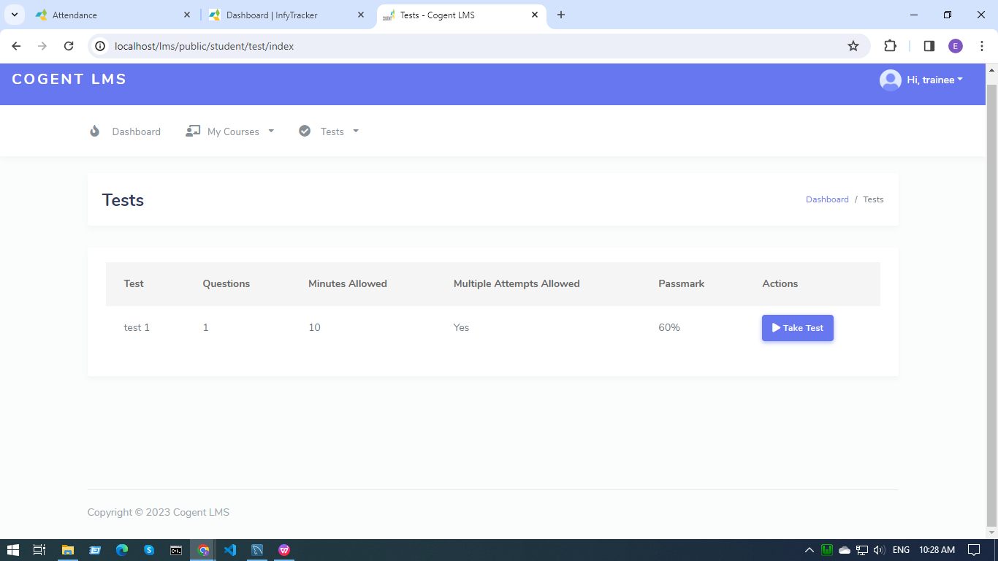

* When trainees click on take test - the start test window will appear

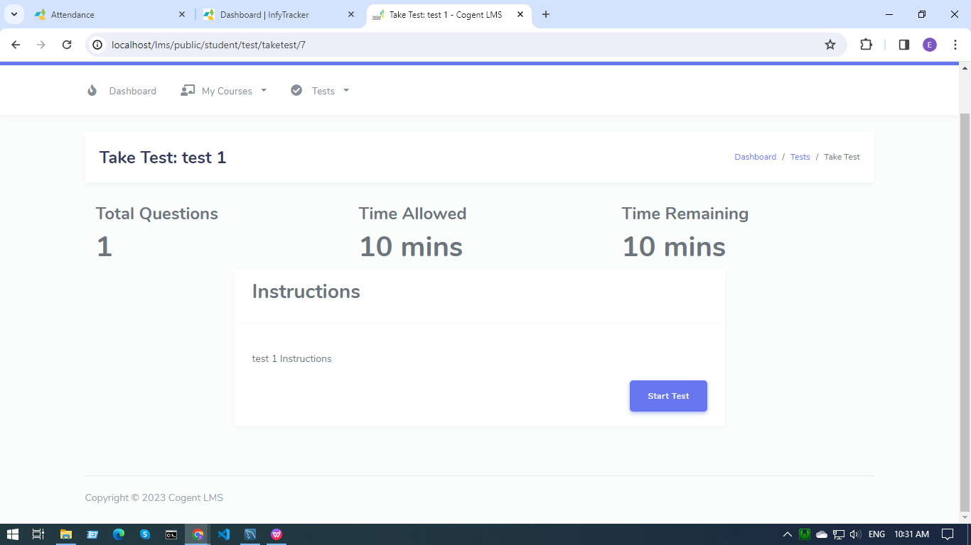

* After starting the test, the window will open.

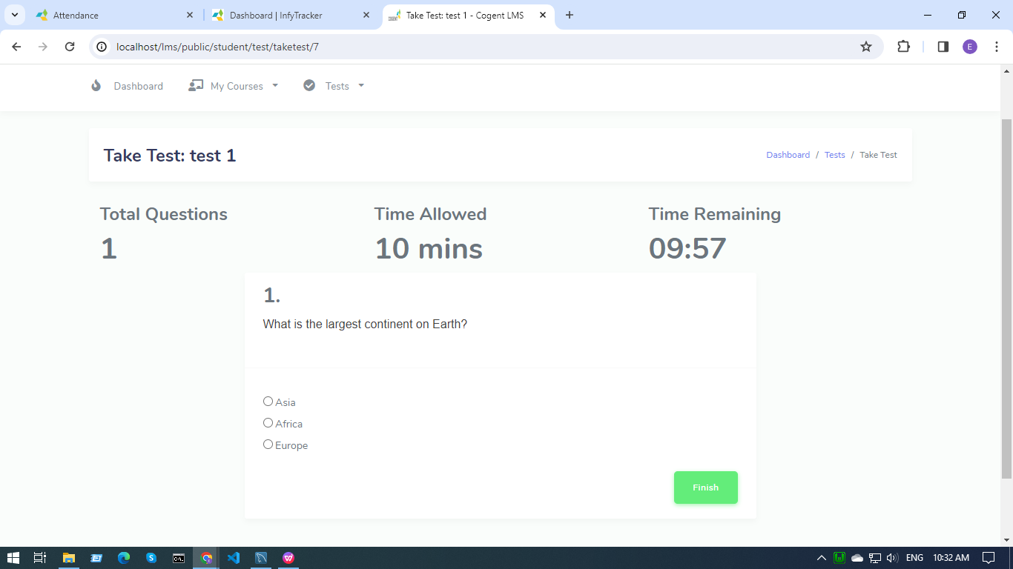

* By clicking on the finish button, a confirmation message will pop up.

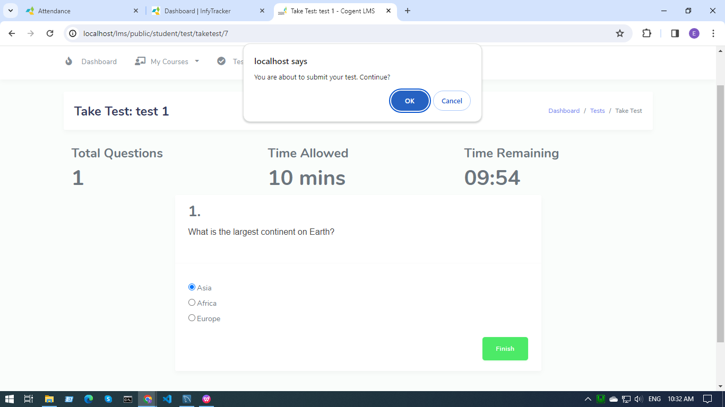

* Once the test is completed, the result screen will be displayed.

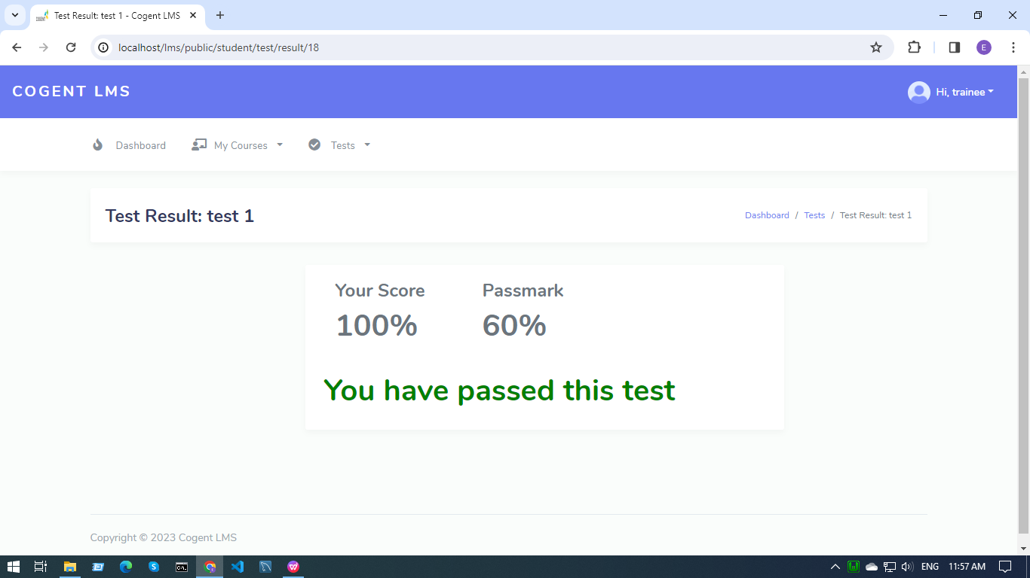

* If the test link is expired, the test expired message will be displayed on the screen.

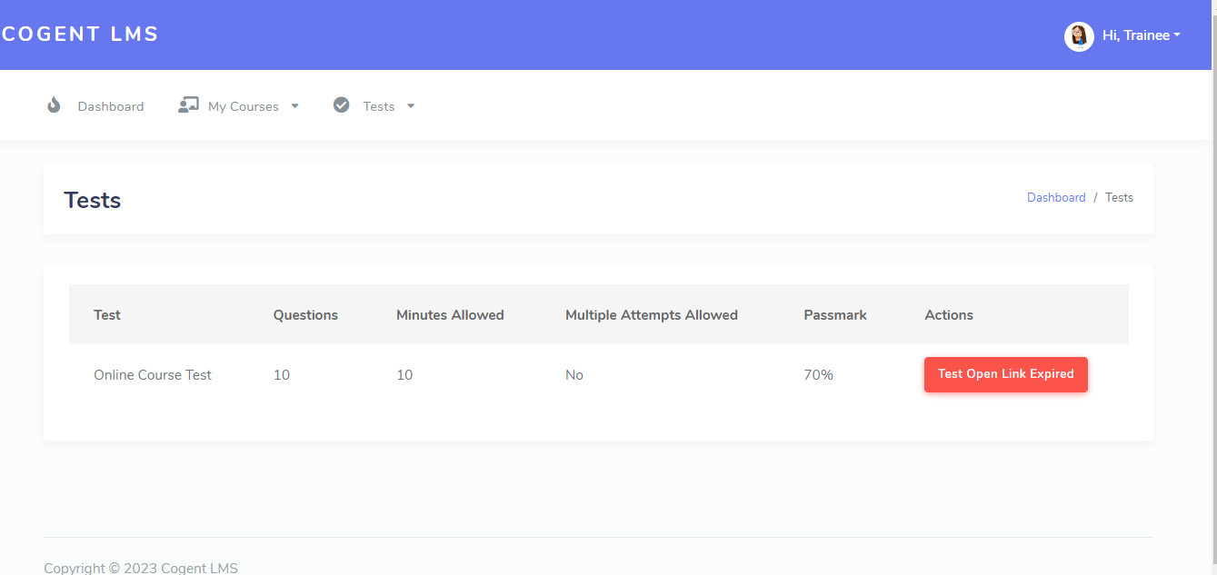

**(Statement of Result) -**

* When a trainee clicks on the statement of result option, the result window displays and the trainee can download the result report by clicking on the download statement button.

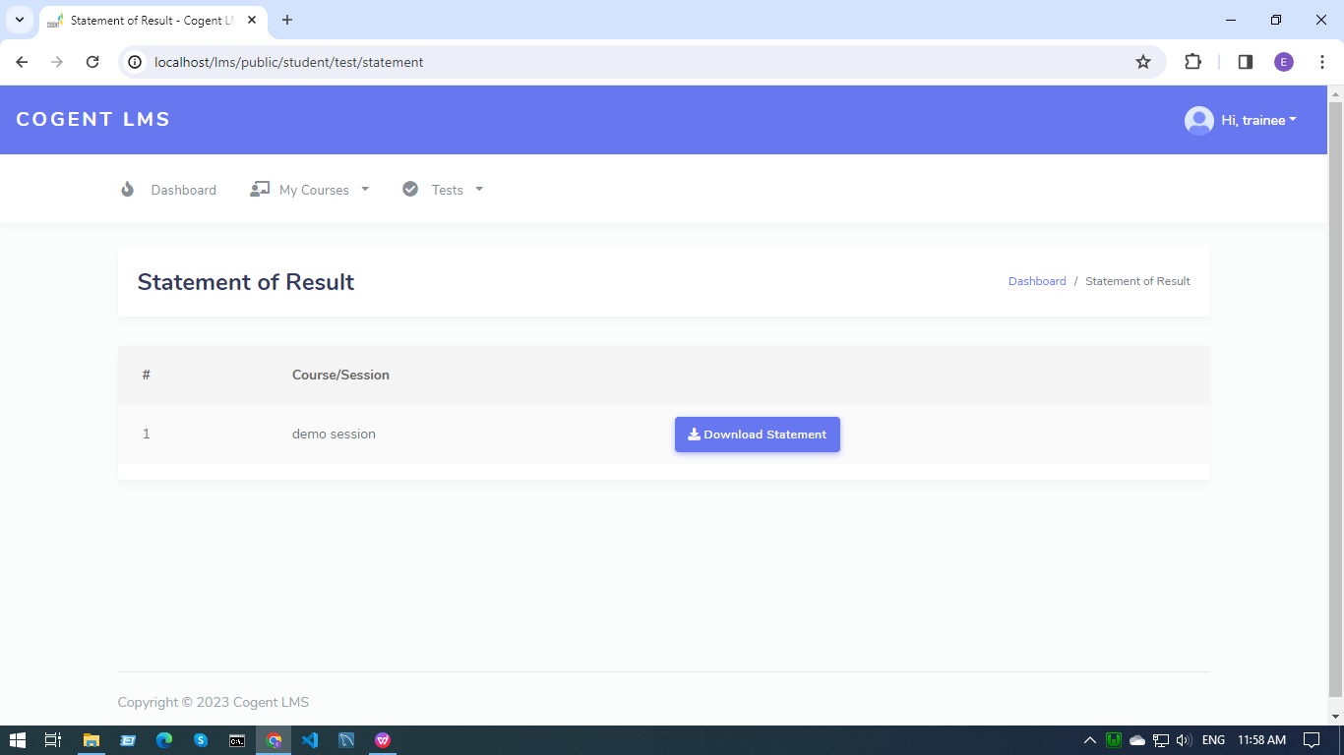

* The result will be given in such a format -

